**DDL Commands – CREATE, ALTER, DROP**

To Create, Alter and Drop the table using Data Definition Language.

1) Create a table name STUDENT with following structure.

mysql> CREATE TABLE STUDENT(RegNo int(3), Name VARCHAR(15), Gender CHAR(1), DOB DATE, MobileNo int(10), City VARCHAR(15));

Query OK, 0 rows affected, 2 warnings (0.03 sec)

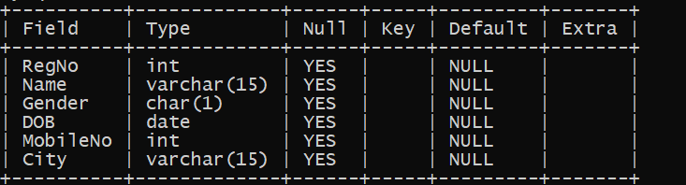

2) Create a table name FACULTY with following structure.

mysql> CREATE TABLE FACULTY(FacultyNo VARCHAR(4), FacultyName VARCHAR(15), Gender CHAR(1), DOB DATE, DOJ DATE, MobileNo int(10));

Query OK, 0 rows affected, 1 warning (0.04 sec)

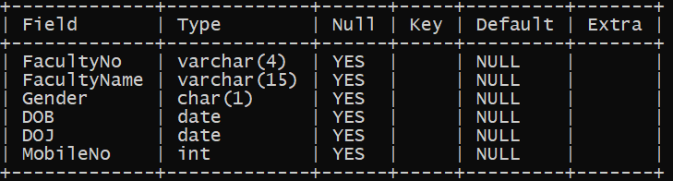

3) Create a table name DEPARTMENT with following structure.

mysql> CREATE TABLE DEPARTMENT(DeptNo VARCHAR(4), DeptName VARCHAR(15), DeptHead VARCHAR(4));

Query OK, 0 rows affected (0.03 sec)

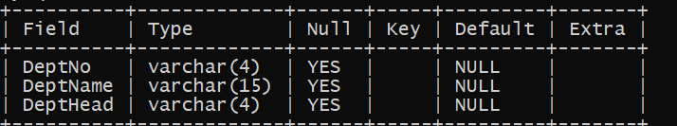

4) Create a table name COURSE with following structure.

mysql> CREATE TABLE COURSE(CourseNo VARCHAR(3), CourseDesc VARCHAR(14), CourseType CHAR(1), SemNo CHAR(1), HallNo VARCHAR(4), FacNo VARCHAR(4));

Query OK, 0 rows affected (0.01 sec)

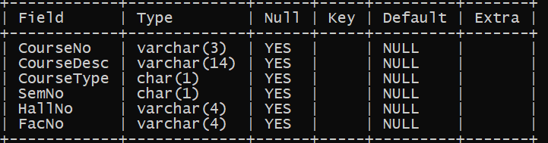

1. Modify the table FACULTY by adding a column name DeptNo of datatype VARCHAR(4)

mysql> ALTER TABLE FACULTY ADD DeptNo VARCHAR(4);

Query OK, 0 rows affected (0.03 sec)

